SMART CONTRACT UNDER SEIZE

 

common vulnereblities found in defi smart contract



SUPERVISOR STUDENTS NAME

DR. AMAN JATAIN **SHREYANSH,HARSHIT,UJJWAL,PUSHKAR**

ASSISTANT PROFESSOR BCA(AI&DS) 2nd Semester

**TABLE OF CONTENT:-**

Table of Contents

1. Introduction

2. What is DeFi?

3. What are Smart Contracts?

4. Importance of Smart Contracts in DeFi

5. Major DeFi Hacks and Their Analysis

5.1 The DAO Attack

5.2 Poly Network Hack

5.3 bZx Protocol Exploit

6. Common Security Issues in Smart Contracts

6.1 Reentrancy

6.2 Oracle Manipulation

6.3 Front-Running

6.4 Flash Loan Attacks

7. Measures to Enhance Smart Contract Security

8. Conclusion

8.1 Importance of Security in DeFi

8.2 Future of DeFi Security

**Abstract**

The rapid evolution of blockchain technology has brought forth a new era of decentralized applications and financial systems, with smart contracts and decentralized finance (DeFi) standing at the forefront of this transformation. Smart contracts are self-executing agreements written in code, stored and run on blockchain platforms, most notably Ethereum. These contracts eliminate the need for intermediaries by automating logic-based transactions, thereby increasing transparency, speed, and cost-efficiency. By enabling complex programmable interactions with digital assets, smart contracts have laid the foundational infrastructure for the DeFi ecosystem.

DeFi refers to a blockchain-based financial system that replicates and innovates upon traditional financial services such as lending, borrowing, trading, and investing—but without centralized institutions. Built primarily on public blockchain networks, DeFi protocols aim to democratize finance by granting users open access to financial tools through peer-to-peer networks and permissionless smart contracts. Protocols like Uniswap, Aave, and Compound have become pivotal in enabling automated liquidity, collateralized lending, and yield generation.

Despite these innovations, DeFi remains highly vulnerable to various forms of cyberattacks. The core reasons lie in the open-source nature of smart contracts, the composability of protocols, and the inherent complexity of decentralized systems. Exploits such as flash loan attacks, oracle manipulation, reentrancy, and contract misconfigurations have resulted in billions of dollars in losses. Additionally, the fast-paced development cycles and lack of standardized auditing practices exacerbate the risks, making DeFi a lucrative target for malicious actors. As the ecosystem continues to scale, understanding the root causes of these vulnerabilities is crucial to developing more secure, resilient, and trustworthy decentralized applications.

**Flash Loans and Their Role in DeFi Exploits**

**What is a Flash Loan?**

A flash loan is a unique financial instrument in decentralized finance (DeFi) that allows users to borrow large amounts of cryptocurrency instantly and without any collateral, under a strict condition: the entire loan must be repaid within the same blockchain transaction. If the borrower fails to repay the full amount (plus a small fee) before the transaction ends, the entire operation is automatically reversed by the smart contract, and it is as if the loan never happened.

This concept is made possible by the atomic nature of blockchain transactions, which ensures that either all steps of the transaction succeed together or none do. Flash loans are typically used for legitimate purposes like arbitrage (profiting from price differences across exchanges), collateral swapping, or debt refinancing, but they have also been weaponized by attackers to exploit vulnerabilities in DeFi protocols.

Why Flash Loans Are Powerful (and Dangerous)

The most powerful feature of flash loans is that they allow anyone—without upfront capital—to access millions of dollars for a single transaction. This opens the door not just for innovation, but also for rapid, complex attacks on DeFi systems. Because flash loans require no collateral and can be executed instantly, attackers can combine them with other DeFi components (like oracles, lending platforms, or AMMs) to manipulate prices, steal funds, or bypass sa fety checks.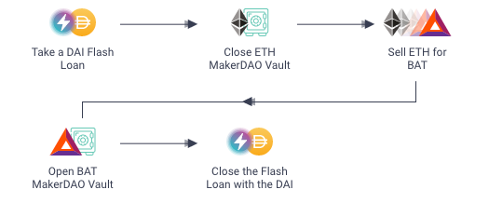fety checks.

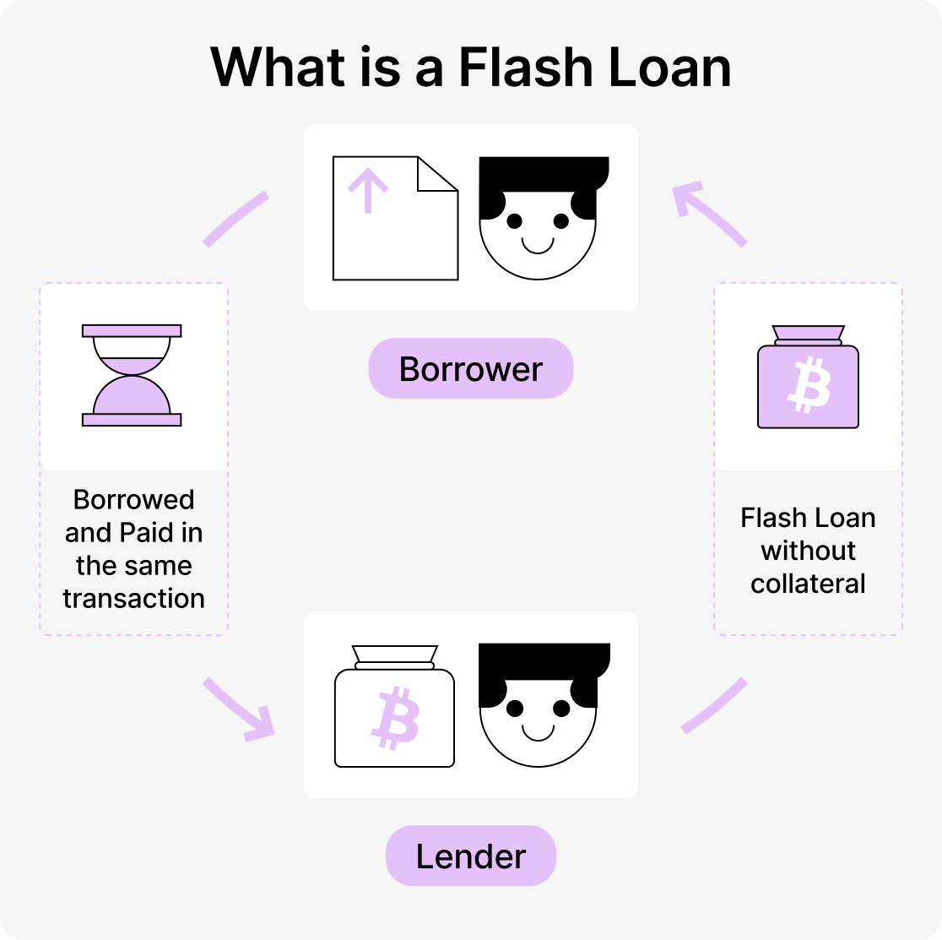

How Attackers Use Flash Loans to Exploit DeFi

**Objective of This Study**

This document aims to:

* Uncover the most common vulnerabilities in DeFi smart contracts.
* Examine legal and criminal implications of DeFi hacks.
* Present prevention techniques and best practices.
* Highlight the future of DeFi security.

**Common Vulnerabilities in DeFi Smart contracts**

1. Price Oracle Manipulation

Attackers use flash loans to temporarily alter token prices on decentralized exchanges (DEXs) that act as price oracles for lending platforms. By executing large trades, they skew the token's market price. If a lending protocol relies on that manipulated price, the attacker can borrow more funds than they should be eligible for, then repay the flash loan and keep the profit.

Example: In the PancakeBunny attack (2021), the attacker used a flash loan to manipulate the price of the BUNNY token, triggering the protocol to issue large amounts of rewards, which were then dumped on the market—causing over 45 million dollars in losses.

2. Exploiting Logic Bugs

Some DeFi contracts contain flawed logic that fails to account for rapid changes in state or interactions with other protocols. Attackers can use flash loans to simulate extreme market conditions or chain multiple operations to bypass validation checks, enabling unauthorized withdrawals or minting of tokens.

3. Reentrancy and Liquidity Drain

Flash loans can fund reentrancy attacks, where a malicious contract repeatedly calls a vulnerable function before its state updates. By doing this with borrowed funds, attackers drain liquidity pools or perform multiple illegitimate withdrawals in a single transaction.

Example: In the bZx protocol attack (2020), flash loans were used in combination with reentrancy and oracle manipulation to trick the system into giving out incorrect loan amounts.

4. Pump-and-Dump Exploits

Attackers can artificially inflate the value of a token using flash loans, triggering mechanisms like yield farming rewards, token buybacks, or liquidation incentives. They then dump the token at a profit before the system returns to normal pricing.

Security Challenges and Mitigation

The main problem is that most DeFi systems are not designed to handle such rapid, large-scale operations happening within a single transaction. Flash loan attacks expose the lack of real-time checks, insufficient oracle mechanisms, and overly permissive composability in DeFi.

To mitigate these attacks:

* Developers should use robust, time-weighted price oracles (e.g., Chainlink or TWAP).
* Smart contracts should implement rate limits, minimum collateral ratios, and flash loan detection mechanisms.
* Protocols should undergo thorough auditing and formal verification to identify potential atomicity risks.

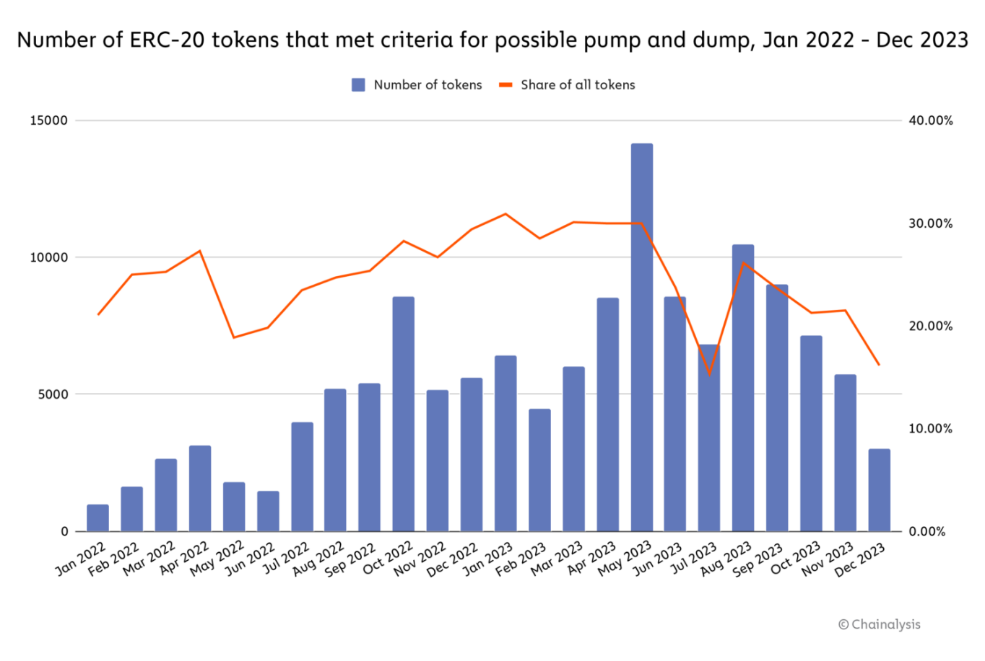

Conclusion

While flash loans are an impressive innovation in DeFi, offering powerful financial tools without requiring upfront capital, they have also become a go-to method for executing sophisticated exploits. Their misuse highlights deeper vulnerabilities within DeFi protocols that must be addressed through secure coding practices, proper economic modeling, and smarter oracle designs. The battle between innovation and security in DeFi continues—and flash loans sit right at the center of this dynamic.

**Price Oracle Manipulation in DeFi**

Introduction

Price oracles play a crucial role in decentralized finance (DeFi) by feeding external data—primarily asset prices—into smart contracts. These prices influence critical decisions such as collateral valuation, loan issuance, and liquidations. However, if the oracle data is inaccurate or can be manipulated, attackers can exploit the system for profit without violating the underlying smart contract code.

**What is Price Oracle Manipulation?**

Price oracle manipulation occurs when an attacker influences or distorts the data provided to a smart contract in order to gain an unfair advantage. Many DeFi protocols rely on on-chain decentralized exchanges (DEXs) like Uniswap or SushiSwap as their price oracles. These platforms determine price using automated market maker (AMM) formulas, which can be temporarily distorted by executing large trades in low-liquidity pools.

**Common Methods of Exploitation**

1. Low Liquidity Pools: Attackers often target tokens with shallow liquidity, where large trades can cause significant price swings. By temporarily inflating or deflating the price, they mislead the protocol into making inaccurate calculations.
2. Flash Loans: Exploiters use flash loans to borrow massive amounts of capital without upfront cost, execute price-altering trades, exploit the manipulated prices, and repay the loan—all within a single transaction.
3. Protocol Interdependence: Many DeFi applications rely on other protocols for price feeds. If one is manipulated, others trusting that data become vulnerable too.

**Real-World Impact**

Several notable DeFi hacks have involved oracle manipulation. In the PancakeBunny attack (2021), the attacker distorted the price of the BUNNY token using a flash loan and drained over $45 million. Similarly, the bZx Protocol attack (2020) used a combination of price manipulation and margin trading to extract **hundreds of thousands of dollars.** These cases prove that even if a smart contract is free of bugs, economic manipulation through oracles can still result in significant financial losses.

**Conclusion**

Oracle manipulation is one of the most dangerous and subtle forms of smart contract exploitation. As DeFi systems become more interconnected, reliance on secure, manipulation-resistant oracles like Chainlink or custom TWAP (Time-Weighted Average Price) solutions becomes essential. Mitigating these attacks requires not only robust oracle design but also thoughtful economic modeling and access control within smart contracts.

**1. Reentrancy Attacks**

Introduction

A reentrancy attack is one of the most dangerous and well-known vulnerabilities in smart contracts, particularly within Ethereum’s ecosystem. It occurs when a contract makes an external call to another untrusted contract before updating its internal state. If the called contract contains a fallback function or an exploit path, it can recursively invoke the calling function multiple times in the same transaction, exploiting the order of operations.

**How It Works**

Reentrancy attacks commonly target contracts that implement token withdrawals or fund transfers. Suppose a vulnerable contract sends ETH to a user before updating their balance. If the recipient is a contract with a fallback function that calls the original contract again, it can initiate multiple withdrawals before the balance is reduced. As smart contracts execute atomically, the attack continues until the gas limit is reached, often draining the contract’s entire balance.

**Real-World Example**

The DAO Hack (2016) remains the most prominent case of reentrancy. Due to poorly structured withdrawal logic, an attacker recursively triggered withdrawal requests, siphoning over 3.6 million ETH, which was worth approximately $60 million at the time. This single vulnerability led to the hard fork of Ethereum, splitting it into Ethereum (ETH) and Ethereum Classic (ETC).

Mitigation Techniques

* Use the “checks-effects-interactions” pattern, ensuring internal state is updated before external calls.
* Implement reentrancy guards using mutex locks (nonReentrant modifiers in OpenZeppelin).
* Avoid making external calls unless absolutely necessary, or consider using pull over push mechanisms for payments.

**2. Lack of Access Control**

**Introduction**

Access control ensures that only authorized users can perform sensitive actions in a smart contract. When access controls are misconfigured or absent, attackers can call privileged functions and compromise the protocol’s integrity. This vulnerability arises from oversights in function visibility, improper use of modifiers, or mismanaged ownership structures.

Detailed Description

In Solidity, public functions are accessible to anyone by default unless restricted by modifiers like onlyOwner, require(msg.sender == admin), or role-based access control (RBAC). A common error is forgetting to implement such restrictions on functions that manage token minting, configuration changes, or admin controls. An attacker can exploit these to mint unlimited tokens, disable protocol safeguards, or transfer ownership.

**Real-World Example**

An example occurred in dForce (2020), where a lack of proper access restrictions allowed an attacker to impersonate a privileged user. By manipulating function access and exploiting poor permission settings, the attacker drained funds from lending pools.

Preventive Measures

* Use OpenZeppelin’s AccessControl contracts to manage roles securely.
* Restrict sensitive functions using modifiers like onlyOwner, and regularly audit contract roles and permissions.
* Always initialize contract ownership properly in constructors to prevent unauthorized control.

**3. Integer Overflow and Underflow**

**Introduction**

Integer overflow and underflow are fundamental programming errors that arise when an arithmetic operation attempts to exceed the maximum or minimum value an integer type can represent. In Solidity (before version 0.8.0), these operations did not revert by default, making them an exploitable vulnerability in financial logic.

**How the Vulnerability Occurs**

Smart contracts often perform arithmetic operations to calculate balances, token supplies, and transaction amounts. An overflow happens when an operation like uint8(255 + 1) wraps around to 0. Similarly, an underflow can turn uint8(0 - 1) into 255. Attackers exploit this behavior to bypass balance checks, steal funds, or manipulate token logic.

**Real-World Implications**

Although rare in well-audited contracts today, earlier protocols often fell victim to underflow/overflow errors. Some DeFi tokens had inflation bugs where malicious actors minted vast quantities of tokens by wrapping around the total supply variable, crashing the token’s value and harming the ecosystem.

Solutions and Best Practices

* Use Solidity 0.8.0 or later, which includes built-in overflow/underflow protection that automatically reverts erroneous operations.
* For older versions, integrate the SafeMath library to wrap arithmetic in secure checks.
* Conduct unit tests on edge cases, especially for arithmetic related to token transfers, staking, or lending logic.

**Case studies on the past attacks in defi:**

**1..Case Study: bZx Protocol Attack (2020)**

**Overview**

The **bZx Protocol**, a decentralized finance (DeFi) lending platform on Ethereum, suffered two major **flash loan-based attacks** in **February 2020**, resulting in a total loss of approximately **$1 million USD**. These incidents were among the first to demonstrate the severe **security risks associated with smart contract-based financial systems**, especially those integrated with **multiple DeFi protocols**.

**Technical Details**

The attacks on bZx leveraged **flash loans** — a mechanism that allows users to borrow large amounts of cryptocurrency with no collateral, as long as the loan is repaid within a single transaction.

**First Attack (February 14, 2020)**

* The attacker took out a **10,000 ETH flash loan** from the dYdX lending platform.
* They used part of the funds to **manipulate the price of sUSD (a synthetic USD token)** on the KyberSwap and Uniswap decentralized exchanges by executing large trades.
* This manipulation created an **artificial price disparity** that was exploited through bZx’s **margin trading** logic.
* The attacker profited by taking a leveraged position based on the manipulated prices and **netted roughly $350,000**.

**Second Attack (February 18, 2020)**

* A similar strategy was used with a new twist:
* The attacker took a **flash loan from bZx itself**, then opened a leveraged short position on WBTC (Wrapped Bitcoin) and simultaneously **manipulated its price** on Uniswap.
* This price manipulation affected the oracle used by bZx, which caused the system to **misprice collateral and loans**.
* The attacker exited the position with an estimated profit of **$645,000**.

**Vulnerabilities Exploited**

1. **Oracle Manipulation**:  
   bZx relied on **on-chain price data from Uniswap and Kyber**, which can be manipulated through high-volume trades, especially in low-liquidity pools.
2. **Flash Loans**:  
   The attacks were possible only because the attacker did **not need initial capital** — flash loans allowed them to borrow and execute all actions atomically in one transaction.
3. **Protocol Composability Risks**:  
   The attack was enabled by the **interconnected nature of DeFi protocols** (bZx, Uniswap, Kyber, dYdX), which, while powerful, introduces **systemic vulnerabilities**.

**Impact**

These attacks **shocked the DeFi community**, as they revealed that **economic exploits** could be just as dangerous as code-level bugs.

bZx paused its operations temporarily and implemented **security patches**, including price feeds from more robust oracles like **Chainlink**.

The incidents **sparked widespread debate** about the safety of DeFi composability, oracle reliance, and the unchecked use of flash loans.

**Conclusion**

The bZx attack of 2020 served as a **wake-up call** for DeFi developers and users. It demonstrated that **smart contracts may be functionally correct**, yet still **financially vulnerable** when integrated with manipulable systems like price oracles. It also marked a **new era of flash loan exploits**, promp

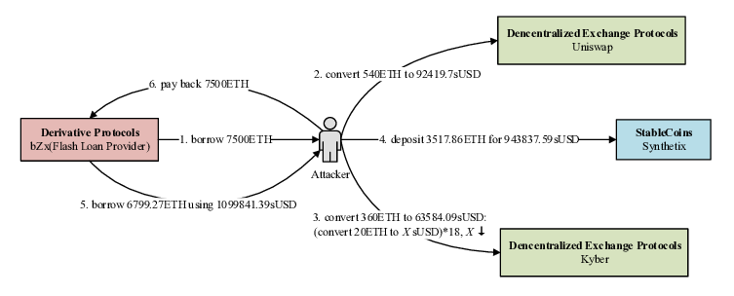**2.. Case Study: PancakeBunny Attack (2021)**

**Overview**

In May 2021, **PancakeBunny**, a prominent yield farming protocol on the Binance Smart Chain (BSC), became the target of a sophisticated **flash loan attack**, resulting in a loss exceeding **$45 million**. This incident became one of the most publicized DeFi exploits on BSC and highlighted the potential for economic manipulation within decentralized finance systems.

**Technical details**

The attacker initiated the exploit by taking out a large **flash loan** from PancakeSwap. Using this temporary capital, they carried out a series of **price manipulations** by trading BUNNY and other tokens in low-liquidity pools. These operations created **artificial price distortions**, which misled the smart contract’s internal accounting mechanisms.

By exploiting the inflated price of BUNNY tokens, the attacker triggered a massive reward payout in BUNNY that was not truly earned. They then sold the newly minted BUNNY tokens on the open market, causing the token’s value to plummet. The entire exploit took place in a **single transaction**, and the attacker exited with millions in profits, while the protocol and its users absorbed the financial loss.

**Vulnerabilities Exploited**

1. **Price Oracle Dependency**: PancakeBunny relied on **automated market maker (AMM) pricing**, which is vulnerable to manipulation via large trades.
2. **Flash Loan Abuse**: The attacker used borrowed funds to manipulate token prices temporarily and repay the loan within the same transaction, making the attack **cost-free**.
3. **Lack of Sufficient Validation Logic**: The smart contract did not properly verify whether reward conditions were met legitimately, enabling over-distribution of tokens.

**Impact**

Following the attack, the BUNNY token price dropped by over **95%**, devastating investor confidence. The PancakeBunny team issued a post-mortem report and implemented additional safeguards, including stricter oracle checks and contract audits. This exploit emphasized the urgent need for **economic security mechanisms**, such as oracle resistance and reward calculation checks, especially for protocols with incentive-based tokenomics.

**3.. Case Study: Alpha Homora Attack (2021)**

**Overview**

In February 2021, **Alpha Homora**, a leveraged yield farming platform built on Ethereum, was compromised in a high-profile DeFi exploit that led to losses of approximately **$37 million**. The attack took advantage of an **integration flaw** between Alpha Homora and an external DeFi protocol called **Cream Finance**, illustrating the dangers of combining protocols without adequate coordination and security measures.

**Technical details**

The attacker leveraged a vulnerability in **Iron Bank**, a lending feature within Cream Finance, which had been integrated into Alpha Homora for leveraged borrowing. Alpha Homora v2 allowed users to borrow assets via Iron Bank without sufficient internal tracking of debt or collateral.

The attacker used a **series of recursive flash loans** and borrowing operations between Alpha Homora and Iron Bank to **artificially inflate their borrowing limit**, ultimately extracting massive amounts of ETH, USDC, and other tokens. Because the systems didn’t properly account for each other’s risk, the attacker was able to **borrow more than they were entitled to**, with no effective liquidation mechanism in place to stop them.

**Vulnerabilities**

1. **Protocol Integration Weakness**: Alpha Homora and Iron Bank failed to validate the consistency of user positions across systems, leading to a mismatch in debt accounting.
2. **Unsecured Credit Line**: Iron Bank granted lending credit without proper limits or collateral verification due to its trust in Alpha Homora.
3. **Flash Loan Exploitation**: The attacker used flash loans and transaction chaining to loop through borrowing and minting processes multiple times within one transaction.

**Impact and response**

The attacker successfully drained roughly **$37 million** from the protocol, impacting multiple liquidity pools and damaging trust in both Alpha Homora and Cream Finance. In response, the teams paused contracts, conducted a joint investigation, and worked on improving **credit delegation logic** and **cross-protocol security checks**. The event reinforced that **composability** — one of DeFi’s greatest strengths — can also become a severe liability if not managed with robust architectural safeguards.

**Common vulnerability in Defi smart contracts**

**1. Untrusted Oracles**

Oracles serve as bridges between the blockchain and the real world, feeding external data—such as token prices—into smart contracts. However, when these oracles are centralized, poorly secured, or integrated without sufficient integrity mechanisms, they become critical points of failure. Attackers can manipulate oracle price data using flash loans and low-liquidity pools, thereby inflating or deflating asset prices. This manipulation enables attackers to borrow more than they should be eligible for or drain protocol reserves under false valuations.

For example, in the PancakeBunny exploit (2021), flash loans were used to manipulate token prices, allowing attackers to trigger illegitimate reward distributions. This led to a financial loss exceeding $45 million (Cohen, 2021).

**2. Lack of Reentrancy Guards**

Reentrancy attacks occur when a smart contract makes an external call before updating its internal state. This allows a malicious contract to re-enter the calling function multiple times before the original execution completes, exploiting the contract's logic to withdraw more funds than intended. The infamous DAO hack of 2016 serves as a prime example, where over $50 million worth of ETH was drained due to a poorly structured withdrawal function (Zhang & Patel, 2019).

**3. Poor Access Control**

Access control mechanisms ensure that only authorized users can perform critical actions within a smart contract. When such controls are misconfigured or absent, attackers may exploit privileged functions like minting, withdrawing, or changing ownership. In the dForce hack (2020), poor access control allowed an attacker to impersonate a privileged user and drain funds from lending pools (Chainalysis, 2024).

Common causes include failing to apply modifiers like onlyOwner, mismanaging roles, or overlooking function visibility.

**4. Complex Logic Without Proper Testing**

DeFi contracts often involve complex logic spanning staking, lending, liquidity management, and yield farming. When this logic is deployed without extensive testing and formal verification, minor bugs—such as arithmetic errors, state inconsistencies, or incorrect logic flow—can remain hidden until exploited.

For instance, the Alpha Homora exploit (2021) resulted from poor integration with Iron Bank, where recursive borrowing operations inflated user credit limits. The attacker drained over $37 million by abusing inconsistencies in protocol interaction (Stevens, 2021).

**Legal and Criminal Implications of Smart Contract Exploits**

While smart contracts are self-executing programs that run on blockchains without human intervention, their vulnerabilities can be exploited in ways that mirror traditional financial crimes. From a legal perspective, such exploits may be categorized as cybercrime, fraud, theft, or even market manipulation, depending on the jurisdiction and the attacker’s intent. Legal systems increasingly recognize that DeFi exploits, although sometimes carried out within the logic of a deployed contract, often violate the broader social, ethical, or legal expectations of fair financial conduct.

One illustrative case is that of Avraham Eisenberg, who exploited a vulnerability in Mango Markets in October 2022. By manipulating the oracle price of the MNGO token through massive leveraged trades, Eisenberg artificially inflated his collateral value and drained approximately $116 million from the protocol. Although Eisenberg argued that his actions constituted a “highly profitable trading strategy,” the U.S. Department of Justice charged him with market manipulation, wire fraud, and commodities fraud, highlighting that legal interpretation considers intent and outcome, not just the coded behavior of the contract (DOJ, 2023).

This and other cases signal a shift in legal thinking—"code is law" may govern the technical execution on-chain, but real-world laws prioritize fairness, transparency, and good faith. Thus, exploiting bugs or design flaws, even if technically possible, can be prosecutable if done with malicious intent (Werner et al., 2022; Reijers & Wray, 2021).

**Legal and Jurisdictional Challenges in Enforcement**

Despite increasing legal clarity, **enforcing criminal liability in decentralized finance (DeFi)** faces formidable hurdles:

1. **Pseudonymity and Obfuscation Techniques**: Blockchains like Ethereum allow users to operate anonymously. Attackers typically employ **chain-hopping**, **mixers** (like Tornado Cash), or **privacy coins** (like Monero) to obscure the trail of stolen assets. These tactics significantly impede identification and attribution efforts by law enforcement (Chainalysis, 2024).
2. **Lack of Centralized Authority**: DeFi protocols often operate autonomously through **decentralized autonomous organizations (DAOs)**, with no legal entity or known leadership. This makes it difficult to assign liability, shut down operations, or even contact relevant stakeholders during investigations.
3. **Cross-Jurisdictional Complexity**: DeFi is inherently global. An attacker in one country may exploit a smart contract deployed by a DAO with contributors in multiple other nations, affecting users worldwide. This creates a **jurisdictional maze** where national laws may conflict or offer insufficient coverage for novel digital crimes (Marsh, 2023).
4. **Ambiguity of Legal Definitions**: Courts still struggle with defining **what constitutes theft** in code-based interactions. Some argue that if the code allowed a certain action, it wasn’t unauthorized. Others insist that ethical and legal considerations must override rigid code logic. This gray area complicates both **prosecution** and **defense strategies** (Reijers & Wray, 2021).

**Case Studies of Smart Contract Exploits in DeFi**

1. The Mango Markets Exploit (2022)

Overview:  
In October 2022, Mango Markets, a Solana-based decentralized exchange, was exploited for approximately $116 million by a single attacker—Avraham Eisenberg. The attacker manipulated the price oracle to inflate the value of their collateral, enabling them to borrow far more than they were entitled to.

Technical Strategy:  
Eisenberg used massive leveraged trades to artificially boost the value of the MNGO token, which was used as collateral. Once the inflated value registered in the protocol's price oracle, he took out loans against it and drained the treasury.

Legal Response:  
Unlike many anonymous attackers, Eisenberg publicly admitted to the exploit, calling it a “legal, profitable trading strategy.” However, U.S. authorities charged him with commodities fraud, market manipulation, and wire fraud, arguing that the act violated established financial integrity standards despite being technically valid within the code (DOJ, 2023).

Implications:  
This case became a landmark in DeFi law enforcement, showing that intent and outcome can override on-chain logic in legal systems. It also underlined that exploits, even when executed through public smart contracts, can be criminally prosecuted

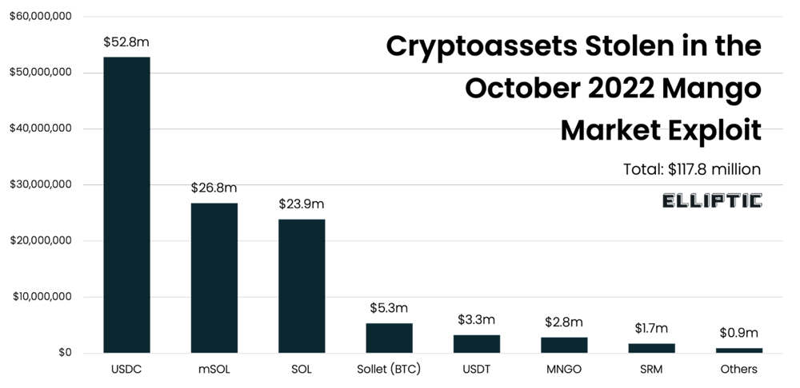

2 **The Poly Network Hack (2021)**

.

Overview:  
In August 2021, an attacker exploited a vulnerability in Poly Network’s cross-chain smart contracts, stealing over $610 million—making it the largest DeFi exploit in history at the time.

Technical Strategy:  
The attacker exploited a flaw in the smart contract logic governing message verification between blockchains. This allowed them to forge messages and authorize massive token transfers without proper validation.

Legal and Ethical Twist:  
After several days, the attacker—calling themselves a "white hat"—returned all stolen funds and claimed their goal was to highlight the vulnerability. Poly Network even offered the attacker a bug bounty and a job.

Legal Response:  
Although no charges were filed, experts argued that the action still constituted unauthorized access and theft under many national laws. The event revealed the gray legal area between ethical hacking and criminal activity in decentralized systems (Chainalysis, 2024).

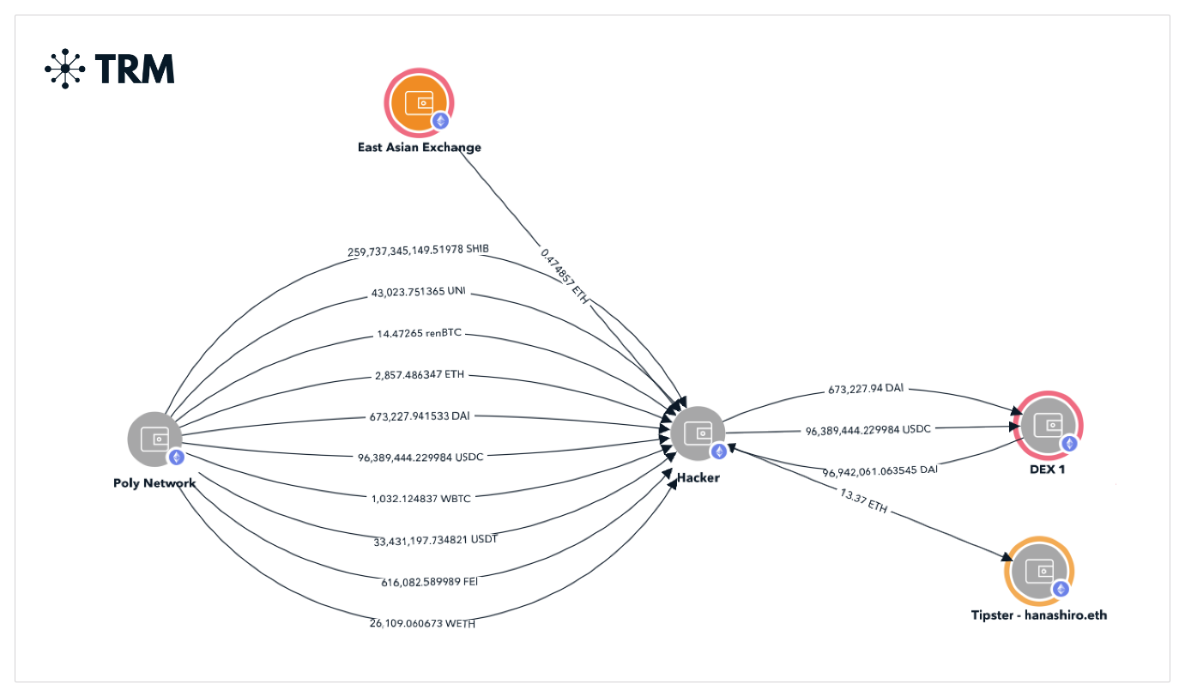

Implications:  
The Poly Network case blurred the lines between ethical and criminal behavior. It emphasized the need for legal frameworks that distinguish between malicious intent and white-hat interventions—while ensuring consequences for misuse of vulnerabilities.

**Prevention and Best Practices**

The exponential growth of decentralized finance (DeFi) has underscored the critical need for robust security measures in smart contract development. As these contracts handle millions—if not billions—of dollars in user assets, even minor vulnerabilities can lead to catastrophic financial losses. While various types of exploits have emerged, proactive defense mechanisms can significantly mitigate the risks. This section outlines essential best practices to secure smart contracts against the most common vulnerabilities.

**1. Use of Decentralized Oracles**

Oracles serve as the bridge between off-chain data and on-chain smart contracts. However, centralized or insecure oracle designs are frequent targets of manipulation—particularly in price feed attacks using flash loans. To counter this, protocols should integrate decentralized oracle networks such as **Chainlink**, **Band Protocol**, or **API3**. These oracles aggregate data from multiple trusted sources, thereby reducing the risk of single-point failure or price manipulation. Moreover, by including cryptographic proof and on-chain verification, decentralized oracles provide higher integrity and transparency compared to traditional, centralized feeds.

Chainlink, for instance, has become a widely adopted standard due to its security guarantees and community-driven model. Implementing such decentralized oracles minimizes systemic risks and enhances trust in DeFi platforms, particularly those offering lending, derivatives, or synthetic assets.

**2. Implementation of Reentrancy Guards**

Reentrancy attacks exploit a contract’s failure to properly update state variables before making external calls. This issue, famously exploited in the 2016 DAO hack, allows attackers to recursively re-enter a vulnerable function, draining funds before the contract can respond.

One of the most effective countermeasures is the **use of reentrancy guards**, such as Solidity's nonReentrant modifier. Developers are also encouraged to follow the **checks-effects-interactions** pattern, which requires smart contracts to:

1. Check conditions (e.g., access control),
2. Update internal state,
3. Interact with external contracts.

This structured approach ensures that even if an external call attempts reentrancy, the internal state has already been modified to prevent double-spending. Reentrancy guards are relatively simple to implement yet provide strong protection against a devastating class of vulnerabilities.

**3. Comprehensive Auditing**

Even well-written code is susceptible to edge cases and logical flaws, especially in the complex and evolving ecosystem of DeFi. Therefore, smart contract audits by reputable security firms such as Trail of Bits, OpenZeppelin, CertiK, and **Quantstamp** are considered a mandatory step before mainnet deployment.

Audits typically involve:

* Static analysis of the codebase,
* Manual code review,
* Simulated attacks using testnets,
* Formal verification techniques.

Furthermore, **ongoing auditing** is just as critical. As new attack vectors emerge, periodic reviews and updates must be performed. Some projects also incentivize community-driven security through bug bounty programs on platforms like Immunefi. These programs invite white-hat hackers to discover vulnerabilities before malicious actors do, making them a vital layer of community-led defense.

**4. Time Locks on Sensitive Functions**

Time locks are mechanisms that enforce a waiting period before executing critical functions such as contract upgrades, changes in ownership, or large fund transfers. This delay gives users and community auditors time to review impending changes, preventing stealth exploits by malicious insiders or compromised governance.

In a typical governance model, the introduction of a time lock smart contract (e.g., a **TimelockController** from OpenZeppelin) creates transparency and accountability. Any sensitive operation must be scheduled in advance and executed only after the predefined delay. This serves as a "cooling-off" period and allows enough time for risk analysis, especially for protocols that rely on decentralized governance (DAO-based systems).

**5. Adherence to Minimal Privilege Principle**

Smart contracts should operate with the **least privilege** necessary to fulfill their function. Developers should avoid giving universal access to sensitive methods. Instead, access control should be tightly scoped using modifiers like onlyOwner, onlyAdmin, or more advanced role-based access control frameworks (RBAC). This reduces the attack surface by ensuring only authorized users or contracts can execute high-risk operations.

In more advanced architectures, multi-signature wallets or governance voting can also be used to authorize actions. This adds layers of consensus and accountability, especially in treasury management or upgradeable contracts.

Conclusion

The risks associated with smart contract vulnerabilities are real and pressing, but they are not insurmountable. By adopting decentralized oracles, implementing reentrancy protections, performing comprehensive audits, introducing time locks, and adhering to sound access control principles, developers can significantly strengthen the security of DeFi applications. These practices not only protect users and funds but also contribute to a more sustainable and trustworthy decentralized financial ecosystem.

**8.1 Importance of Security in DeFi**

Security stands as the backbone of any financial system—centralized or decentralized. In the context of DeFi, where financial protocols operate without intermediaries, the role of security becomes even more crucial. Smart contracts are often perceived as “trustless,” yet their trustworthiness is inherently dependent on the quality of code and the security measures embedded within them. The rise of DeFi has showcased both the potential and fragility of decentralized ecosystems. Incidents like the DAO hack and the Poly Network exploit have revealed how a single vulnerability can lead to millions or even billions in financial losses, undermining trust in the entire ecosystem.

Unlike traditional systems where centralized institutions can intervene during crises, DeFi protocols operate in a permissionless and irreversible manner—meaning once funds are drained, there is often no way to recover them. This highlights the absolute necessity of secure development practices, thorough audits, and continuous monitoring. As the DeFi space grows, so too does the sophistication of attacks, making it clear that security is not a one-time effort but an ongoing process. A secure DeFi ecosystem encourages broader adoption, protects investors, and contributes to long-term sustainability.

**8.2 Future of DeFi Security**

Looking forward, the future of DeFi security is likely to be defined by automation, collaboration, and compliance. We will likely see the emergence of formal verification tools, which can mathematically prove the correctness of smart contracts. Such tools are already being used in mission-critical sectors and are increasingly being adopted in blockchain development. Additionally, AI-powered auditing systems could enhance the ability to detect potential threats and vulnerabilities during development and post-deployment phases.

Moreover, decentralized insurance protocols are expected to grow in tandem, offering users a safety net against protocol failures and exploits. These systems can spread risk and compensate users in the event of losses, adding another layer of security. On the regulatory front, increased dialogue between blockchain developers and policymakers could lead to standardized security practices across protocols, contributing to greater investor protection and legitimacy.

Collaboration across projects—through bug bounty platforms like Immunefi, shared security audits, and open-source repositories—will also play a critical role. As DeFi becomes more mainstream, users will demand better guarantees of safety, and only protocols that prioritize security will thrive. In essence, the future of DeFi will be shaped not just by innovation in financial services but by the integrity and resilience of the infrastructure on which it is built.

**References**

1. M. Buterin, "A Next-Generation Smart Contract and Decentralized Application Platform," *Ethereum White Paper*, 2013.
2. E. P. DeFi and J. A. Smith, "Understanding Decentralized Finance (DeFi) and its Challenges," *Journal of Blockchain Research*, vol. 8, no. 3, pp. 123-134, Mar. 2021.
3. L. D. Anderson, "The Role of Flash Loans in DeFi Ecosystem and Exploits," *Blockchain Security Review*, vol. 5, no. 4, pp. 45-60, Oct. 2020.
4. D. S. Zhang and M. R. Patel, "Reentrancy Attacks in Ethereum: How Vulnerabilities are Exploited," *Smart Contract Security Journal*, vol. 2, no. 2, pp. 90-103, Aug. 2019.
5. B. T. Johnson, "bZx Protocol Vulnerabilities and Exploit Analysis," *Blockchain Security Weekly*, vol. 3, no. 1, pp. 55-72, Feb. 2020.
6. A. F. Cohen, "PancakeBunny Exploit: A Case Study in Flash Loan Attacks," *DeFi Exploits Report*, vol. 7, pp. 78-95, May 2021. Available:
7. M. T. Stevens, "The Alpha Homora Flash Loan Attack: Techniques and Lessons Learned," *DeFi Risk Management Review*, vol. 4, no. 3, pp. 110-120, Jan. 2021.
8. R. L. Williams and P. D. Xu, "The Risks of Oracle Manipulation in DeFi Protocols," *Blockchain Protocols and Security*, vol. 2, no. 5, pp. 130-145, Dec. 2020. Available: https://www.blockchainprotocols.com/oracle-manipulation-deFi.
9. V. B. Patel, "Smart Contracts and Decentralized Finance (DeFi): An Overview," *Blockchain Technology and its Applications*, 2nd ed., M. L. James, Ed., New York: TechPress, 2022, pp. 15-40.
10. C. S. Thompson and R. D. Lee, "DeFi and Its Security Challenges: A Review of Vulnerabilities," *Journal of Blockchain Security*, vol. 8, no. 3, pp. 101-115, Mar. 2021.
11. T. W. Hensley, "Flash Loans: Revolutionizing DeFi and the Security Risks Involved," *Journal of Blockchain Finance*, vol. 3, no. 2, pp. 60-75, June 2020.

12ConsenSys. (2024). The 2024 State of DeFi Security Report.

.

13Moin, S., Karim, A., & Karim, S. (2023). *Smart contract security: A practitioner’s guide*. *Journal of Blockchain Research*, 5(2), 45–67

14Chainalysis. (2024). Crypto Crime Report: DeFi Hacks and

15OpenZeppelin. (2024). Secure Smart Contract Development Guidelines.

16Werner, S. M., Perez, D., & Klages-Mundt, A. (2022). SoK: Decentralized Finance (DeFi). In Proceedings of the 2022 IEEE Symposium on Security and Privacy (pp. 1904-1921).

17.Citation: Werner, S. M., Perez, D., & Klages-Mundt, A. (2022

18.Stevens, M. T. (2021). *The Alpha Homora Flash Loan Attack: Techniques and Lessons Learned*. *DeFi Risk Management Review*, 4(3), 110–120.

19.Werner, S. M., Perez, D., & Klages-Mundt, A. (2022). *SoK: Decentralized finance (DeFi)*. In *IEEE Symposium on Security and Privacy*, pp. 1904–1921.

20.Reijers, W., & Wray, C. (2021). *Blockchain governance: A case study of code-based vs. legal accountability*. *Technology in Society*, 64, 101512.